Practical 1: Flight Reservation System using Cloud Service Provider (SaaS)Resource Pooling

Aim
To create a simple cloud-based Flight Reservation System using a Cloud Service Provider (such as Google AppSheet, Microsoft Power Apps, or Zoho Creator) to demonstrate the Software as a Service (SaaS) model.

Procedure
- Sign in to the selected Cloud Service Provider.
- Create a new cloud application.
- Design a Flight Reservation form with fields such as Passenger Name, Flight Number, Source, Destination, Date of Journey, Seat Class, Contact Number, and Payment Status.
- Create a cloud database to store reservation details.
- Configure forms for adding, updating, deleting, and viewing reservations.
- Test the application by entering sample flight booking details.
- Verify that all data is stored and accessed through the cloud.
- Save and publish the application to demonstrate SaaS functionality.

Implementation

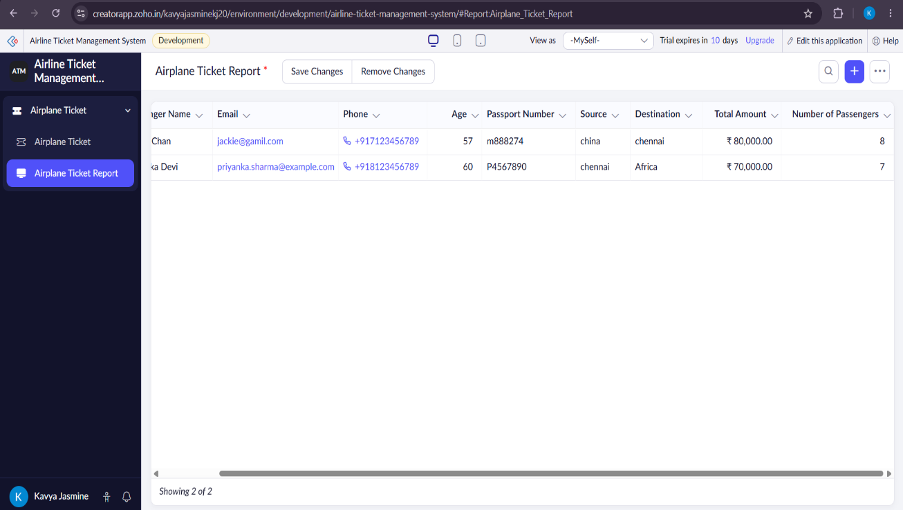
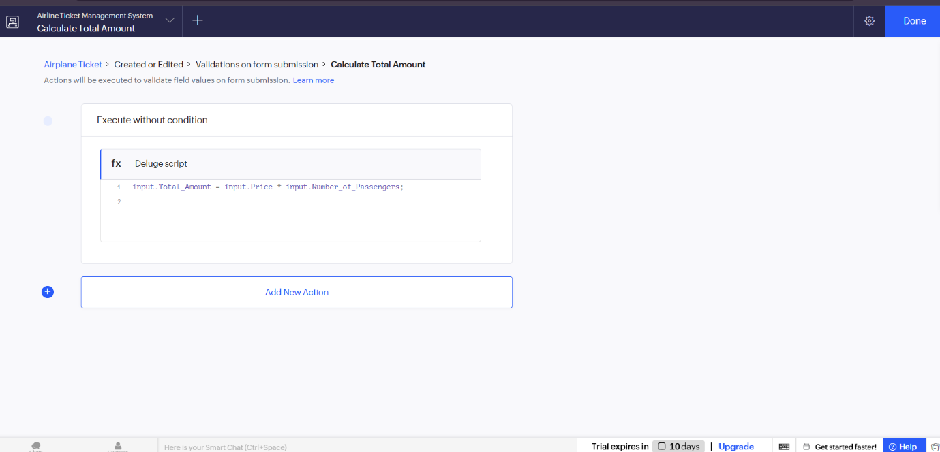
The Airplane Reservation System was successfully developed using Zoho Creator. The application allows users to manage flight bookings, store passenger information, verify seat availability, generate reservation reports, and automate booking confirmations, providing an efficient cloud-based reservation system.

